**Programs on Inheritance and Interface**

1. Write a program to take Patient’s information from Question 31 and add doctor’s details using inheritance.

1. Write a program to demonstrate the overriding of a method to returns the product of given numbers. Use the super keyword.

**Logic:**

Step 1: Start

Step 2: package welcome;

Step 3: class p_1

Step 4: So, we have to first declare a class p_1 and declare required variables.

Step 5: Now after this we also have to declare a constructor that will receive two integers.

Step 6: After that declare a void class that will print the result.

Step 7: Now declare another class p_2 that will extend the previous class.

Step 8: So, after step 7 use super keyword that will transfer the vales to the precious class.

Step 9: Now we have to declare a method that will use super keyword to the method in the previous class.

Step 10: After all this just declare the main class that will call the p_2 class and transfer values to it.

Step 11: Stop

**Code:**

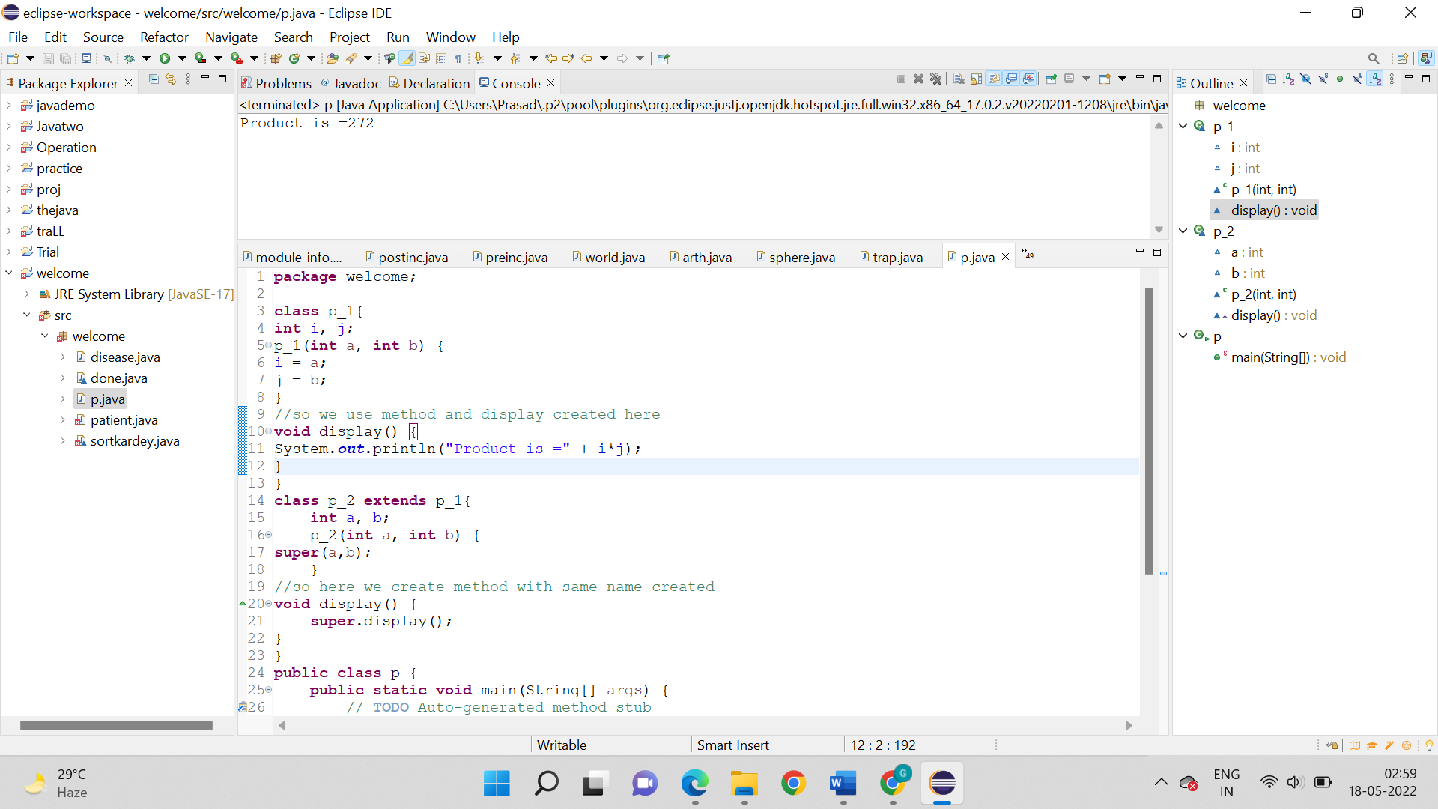

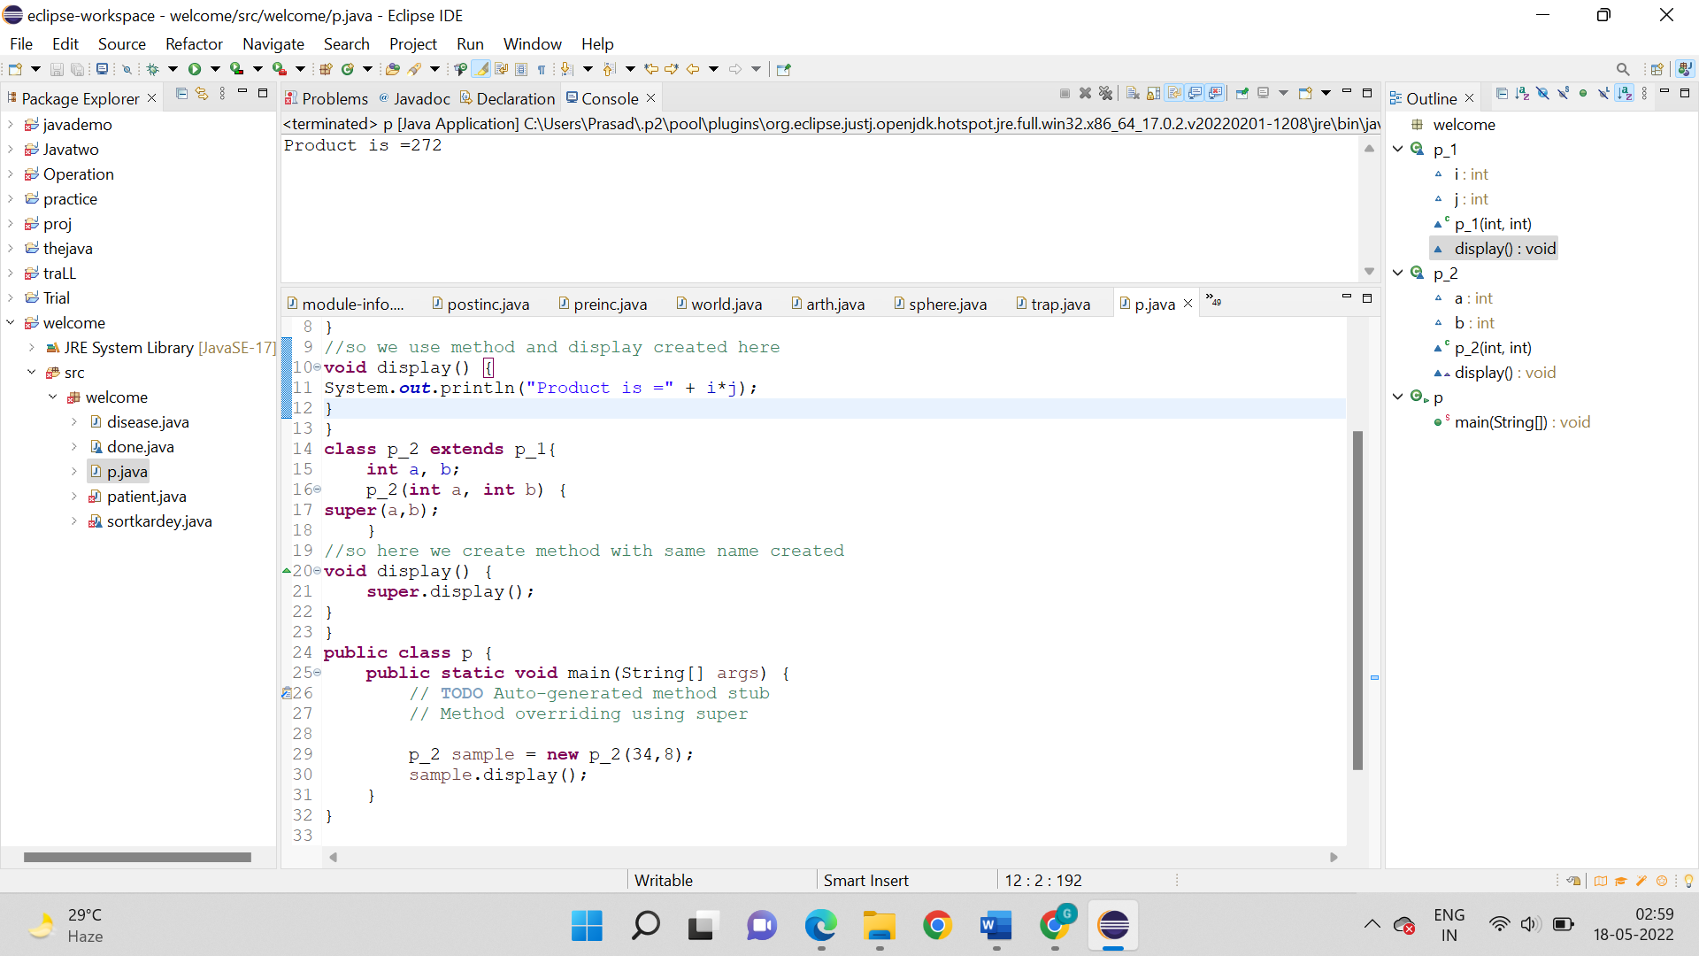

**Output:**



1. Write a program to demonstrate dynamic method dispatch to calculate the area of the following figures:
2. Rhombus
3. Triangle
4. Rectangle

**Logic:**

Step 1: Start

Step 2: package welcome;

Step 3: class dynamic{

Step 4: So, just declare a class figure. It will consist of two variables and a constructor that will receive the values from the main class.

Step 5: Now we have to then declare a void class that will print a statement upon calling.

Step 6: Just we have to further declare three classes rectangle, triangle and rhombus, each of them will have their own constructors and will extend to the class figure.

Step 7: After step 6 we have these three classes will have a method that will return area of the respective shape.

Step 8: After that these classes will also have a void method that will print the area of the shape.

Step 9: Now let us get back to the main class. The main method will call for the rectangle, triangle and rhombus class and transfer value to the classes and finally get result.

Step 10: Stop

**Code:**

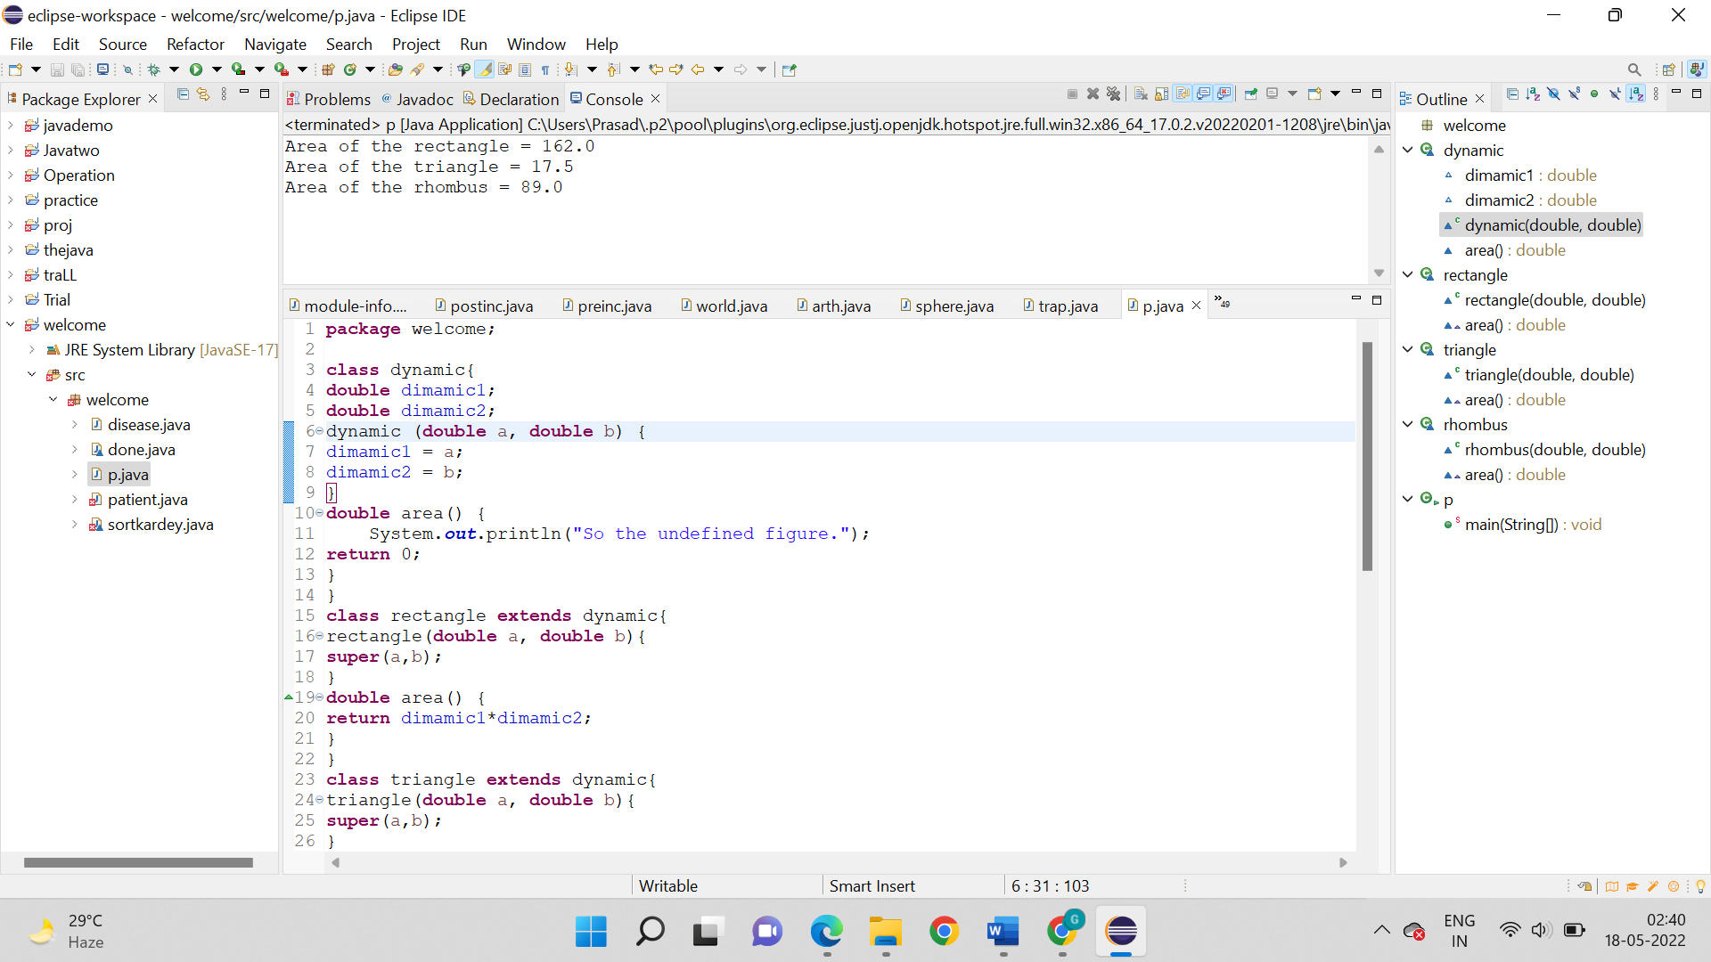

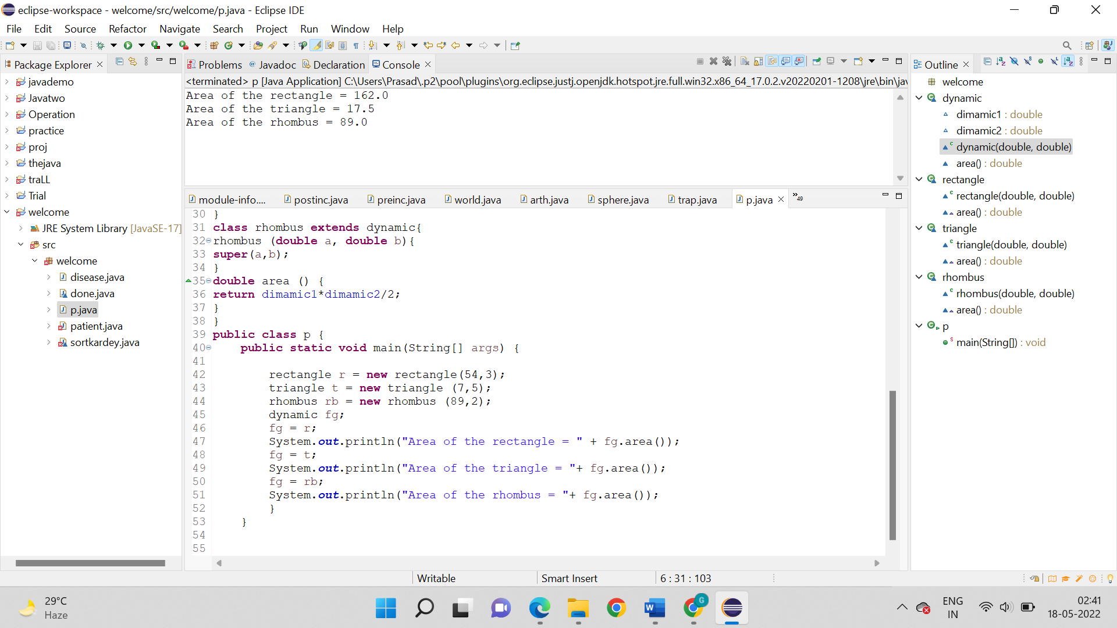

**Output:**



1. Write a program to demonstrate the use of the interface to calculate the addition, subtraction, multiplication, and division of two numbers. Create a method of the arithmetic operator.

**Logic:**

Step 1: Start

Step 2: package welcome;

Step 3: interface Calc{

Step 4: First of all we declare an interface using the “interface” keyword.

Step 5: Now the interface has a method that will hold two integers.

Step 6: After that just declare a subclass that is inherited from the interface using “extends” keyword.

Step 7: After done with step 6 just declare a method inside the class that will receive value from the interface and print the required arithmetic calculation.

Step 8: Now we have to declare the main class, that will make a call to the subclass and transfer values to it.

Step 9: Stop

**Code:**

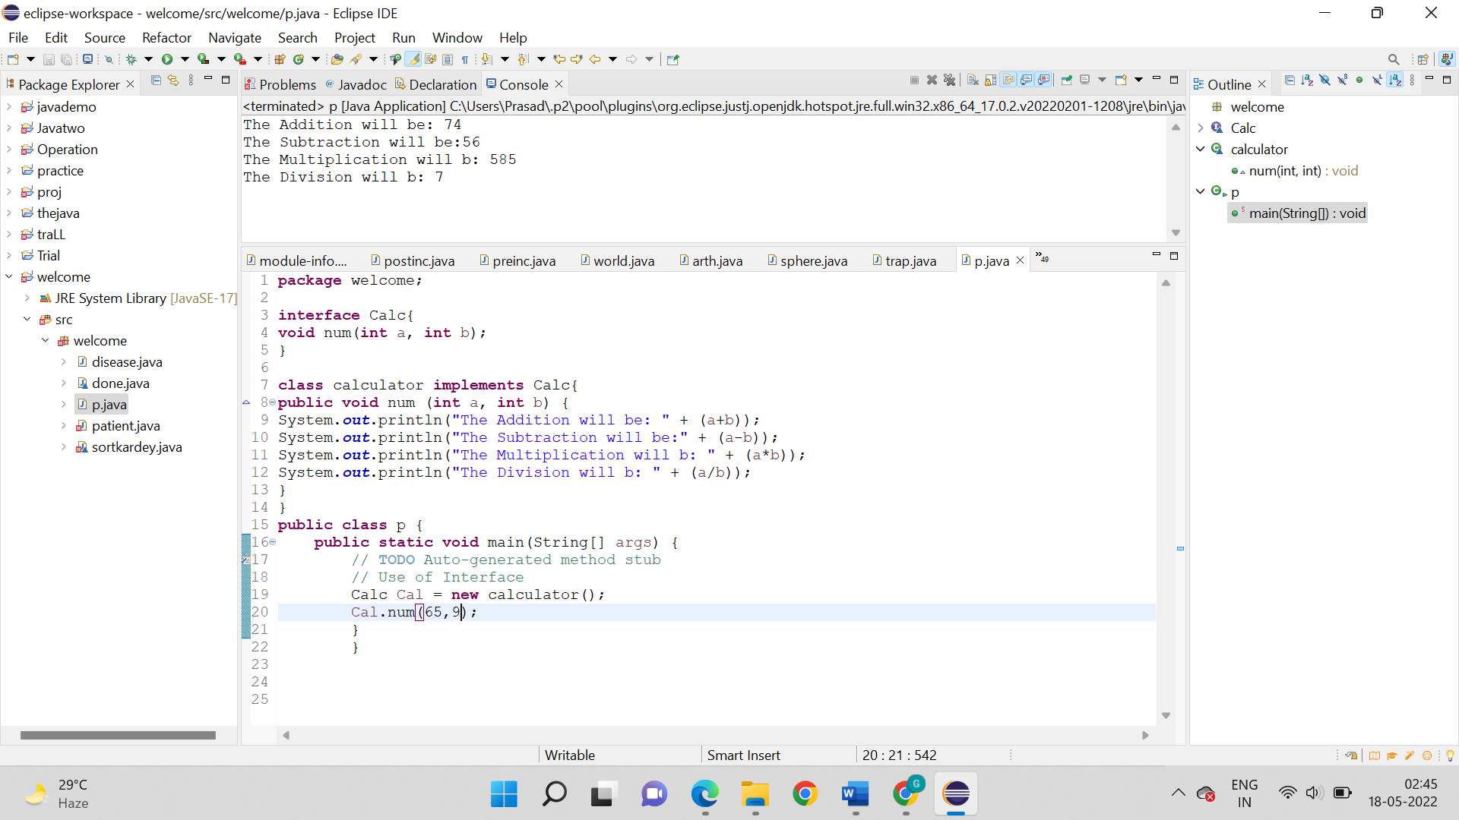

Output:



1. Write a program to demonstrate the use of Interface calculate the area of the following figures:
2. Rhombus
3. Triangle
4. Rectangle
5. Circle

**Logic:**

Step 1: Start

Step 2: package welcome;

Step 3: interface dimension{

Step 4: First of all declare an interface and a method inside it that will hold the required float values.

Step 5: Now we have to declare a class that will implement the interface.

Step 6: After that just declare a method inside the class that will receive the values from the main class and calculate the areas of respective shape prints the result.

Step 7: Now just in the main class, the we call the sub-class and transfer the values to the method

Step 8: Stop

**Code:**

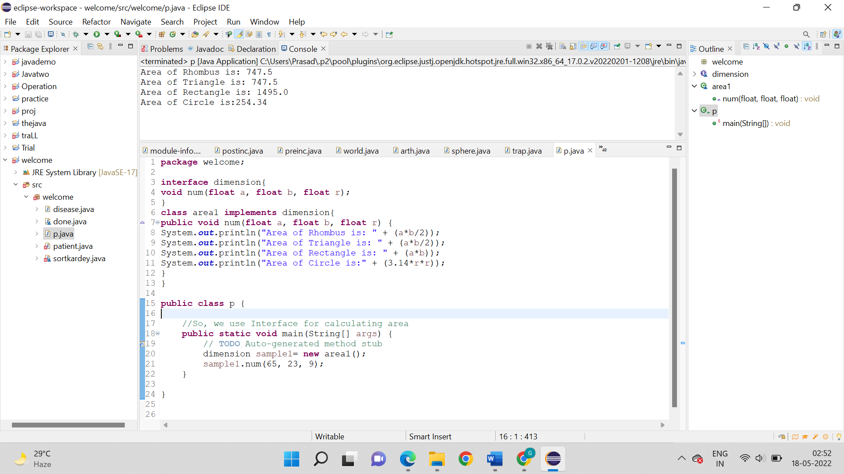

**Output:**

